# 浏览式阅读

## 1 自己的总结、评价以及应用

本文是对multi-view learning做的一个survey，一个overview。

首先澄清一个概念：什么是multi view

These views may be obtained from multiple sources or different feature subsets（特征子集）.

For example, a person can be identified by face, fingerprint, signature or iris with information obtained from multiple sources, while an image can be represented by its color or texture features, which can be seen as different feature subsets of the image.

当前研究分类：

we review a number of representative multi-view learning algorithms in different areas and classify them into three groups: 1) co-training, 2) multiple kernel learning, and 3) subspace learning.

以上研究分类的共同点：

they mainly exploit either the consensus principle（共识原则） or the complementary principle（互补原则） to ensure the success of multi-view learning.简而言之， the consistency and complementary properties of different views.

## 2 文章的主要问题（abstract、疑问句中）

本文就介绍了这样一个东西：Torchreid以及它的几大特性

a software library built on PyTorch that allows fast development andend-to-end training and evaluation of deep re-ID models

## 3 结论（abstract以及conclusion中）

## 4 思路脉络（小标题中的关键句）

1. **Introduction**

首先说数据：

variables of each data example can be naturally partitioned into groups, Each variable group is referred to as a particular view.

本文就干了这一件事：

This motivates us to design a generic framework that provides a standardised data-loading interface, basic training pipelines compatible with different re-ID models, and more importantly, is easy to extend

对multi-view的图展示：

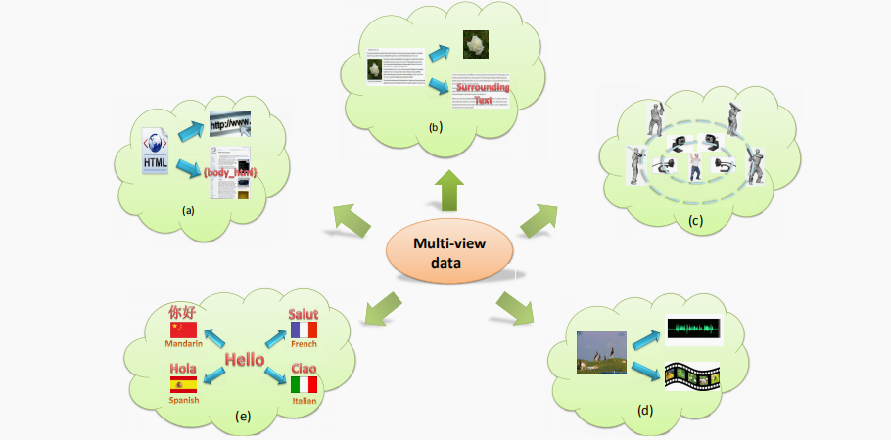

multi-view learning as a new paradigm introduces one function to model a particular view and jointly optimizes all the functions to exploit the redundant views of the same input data and improve the learning performance.

三种主流的学习方法：

1. Co-training

It trains alternately to maximize the mutual agreement on two distinct views of the unlabeled data.

1. Multiple kernel learning

Multiple kernel learning (MKL) was originally developed to control the search space capacity of possible kernel matrices to achieve good generalization but has been widely applied to problems involving multi-view data.

1. Subspace learning-based approaches

Subspace learning-based approaches aim to obtain a latent subspace shared by multiple views by assuming that the input views are generated from this latent subspace.

它的一个优点：其处理的latent subspace的维数较低，可以提高运算效率

The dimensionality of the latent subspace is lower than that of any input view, so subspace learning is effective in reducing the “curse of dimensionality”

下面对文献的各个部分进行说明：

Section2:

we first illustrate the principles underlying multiview learning algorithms in Section 2.

Section3:

different approaches to the construction of multiple views and methods to evaluate these views are introduced.

Section4:

We present different ways to combine multiple views in Section 4

Section567:

illustrate different kinds of multi-view learning algorithm in detail in Sections 5, 6 and 7.

Section8:

The applications of multi-view learning are introduced in Section 8

Seciton9:

experimental results reflecting the performance of multi-view learning are shown in Section 9.

Section10:

we conclude the paper in Section 10.

1. Principles for Multi-view Learning

Multi-view learning的一个关键问题：

considering the relationships between multiple views.

there are two significant principles ensuring their success: consensus and complementary principles.

* 1. Consensus Principle

共识原则的目标就是尽可能的增大两个不同view的consensus，因此有下面的一系列的共识限制方法。

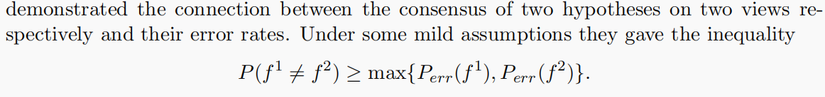

From the inequality, we conclude that the probability of a disagreement of two independent hypotheses upper bounds the error rate of either hypothesis. Thus by minimizing the disagreement rate of the two hypotheses, the error rate of each hypothesis will be minimized.

1. In the co-regularization algorithm, the consensusprinciple can be formulated by regularization terms as



1. 

2.2 Complementary Principle

The complementary principle states that in a multi-view setting, each view of the data

may contain some knowledge that other views do not have; therefore, multiple views can be employed to comprehensively and accurately describe the data.

Thus by considering the complementary information underlying various views of the data and combining multiple kernels from these distinct views, a comprehensive measurement of the similarity can be obtained.

1. View Generation

在这一块，主要是构建多视图数据和对这些视图进行评估。

* 1. View Construction

从单一视图中构建多视图：the construction of multiple views from this single view

下面是流程：

Generating different views-->特征划分feature set partitioning-->特征选择/挑选 feature selection

又一个简单可行的方法：

A simple way to convert from a single view to multiple views is to split the original feature set into different views at random.

可用算法推荐：

there indeed a number of experiments in multi-view learning employing this trick (Brefeld et al., 2005; Bickel and Scheffer, 2004; Brefeld and Scheffer, 2004)

下面介绍一个具体的算法：

The random subspace method

For a given feature space of n dimensions, there are 2n such selections that can be constructed.All the subspaces can then be regarded as different views of the data.（n维特征空间可以提取出2**n个subset，也就是可以对应2**n个不同的view）

当然下面还有好多方法，不再一一介绍。

* 1. View Evaluation

View evaluation中的一个问题：view disagreement problem

简要陈述：来自每一个view的样本可能不属于同一个class

1. View Combination

传统的view combination方法是将multi-views连接到一个single-view。

我们的解决办法：we resort to advanced methods of combining multiple views to achieve the improvement in learning performance compared to single-view learning algorithms.

下面是一些具体的解决算法：

Co-training style algorithms：

为每一个view设置一个learner，然后不同的learner相互学习，增大agreement、缩小disagreement，以达到最优解。

1. Co-training Style Algorithms
   1. Assumptions for Co-training
2. Subspace Learning-based Approaches

得到一个被所有view所共享的latent subspace

7.1 Algorithms based on CCA

CCA:典型相关分析

7.1.1 A review of CCA

。。。。。。说了一大堆公式，最终就是求两个图像矩阵X Y的相关性（相关系数）。CCA主要是解决线性相关性问题的。

7.1.2 Kernel CCA（用于解决non-linear数据集的线性映射问题）

某些datasets是non-linear的，而CCA本身是linear的，为了使用CCA处理这些non-linear的datasets，CCA将这些数据map到一个更高维的空间中，这样就可以使用CCA kenel的线性方法来处理这些数据了。

7.1.3 Theoretical analysis of CCA

看不懂啊

7.1.4 Related algorithms with CCA

7.2 Multi-view Fisher Discriminant Analysis（判别分析）

监督学习方式

7.2.1 Two view Fisher Discriminant Analysis

关键：一个优化问题：

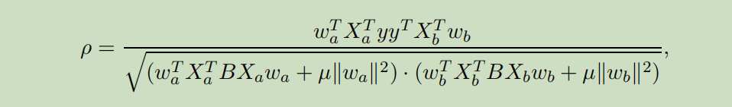

7.2.2 Kernel two view Fisher Discriminant Analysis

Kernel的实质：就是外加两个 dual weight vectors（双重权重向量），新的优化函数变为：

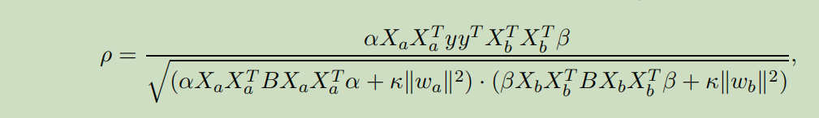

7.3 Multi-view Embedding

Multi-view Embedding，Embedding的本质其实就是对数据做降维处理，将数据从高维降到低维以后，然后再计算i-th view的imgs之间的概率分布（距离分布）（矩阵），然后就可以计算两个概率分布之间的 KL divergence，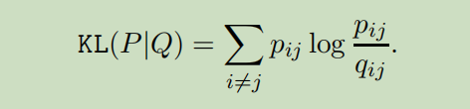

再然后就可以计算objective function了。

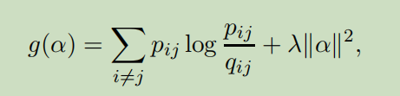

7.4 Multi-view Metric Learning

在度量学习中，求目标损失函数的步骤：

1 两个特征向量vector



2 将两个特征向量vector进行映射project，分别使用映射函数g1 g2，得到映射后的“特征向量vector”，分别如下：

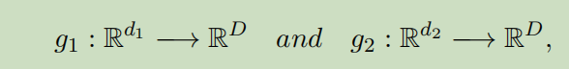

其中，两个映射函数分别为



3 下面就可以得到目标损失函数了

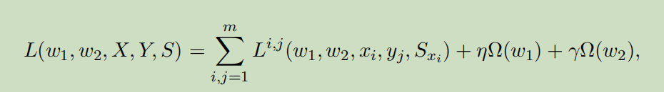

8. Applications

应用多多：

web document classification problem、multiple kernel learning、Subspace learning

9. Performance Evaluation

首先说一下multi-view中常用的dataset

Data Sets for Multi-view Learning：

贴几张图：

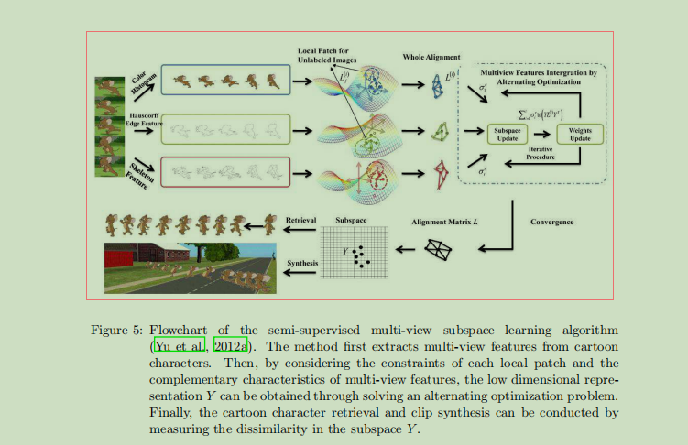

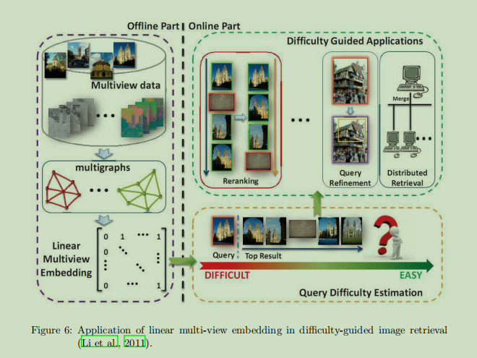

扒一张图

